ROS2 Set-up
There are three ways you can access ROS2.
- SIE Computing Lab: ROS2 Jazzy Jalisco and Virtual Machine are installed on the first 2 rows of computers in the SIE Computing Lab through Oracle VM VirtualBox. I have ensured all appropriate packages are set up and working.
- Install Oracle VM VirtualBox and Jazzy Jalisco VM on your machine: I can provide the ROS2 virtual machine on USB or you can downloaded it from the class page – note this is a very large file so please ensure you have a stable internet connection before starting to download it.
- Install Jazzy Jalisco on your machine: Installation is supported for Ubuntu and Windows and instructions can be found here: https://docs.ros.org/en/jazzy/Installation.html. Note, all tutorials and instructions for the course are made for the Virtual Machine which is running Ubuntu, so if you install on Windows I cannot guarantee they will work seamlessly, but I will do my best to support your use.

Oracle VM VirtualBox Set-Up (Option 2):
- Enable hardware virtualization
You need to ensure hardware virtualization is enabled in your BIOS for your computer. This is unfortunately a manufacturer specific step. Below is a description of the steps, as general as I can make them.
- Reboot your computer
- Right when the computer is coming up from the black screen, press Delete, Esc, F1, F2, or F4. Each computer manufacturer uses a different key but it may show a brief message at boot telling you which one to press. If you cannot determine the correct button to press you can search online using the manufacturer of your computer (for instance Lenovo) + “boot to BIOS” to find more specific instructions. If you miss it the first time, reboot and try again. It helps to tap the key about twice a second when the computer is coming up. If you are not able to enter the BIOS via this method, consult your computer’s manual.
- In the BIOS settings, find the configuration items related to the CPU. These can be in under the headings Processor, Chipset, or Northbridge.
- Enable virtualization; the setting may be called VT-x, AMD-V, SVM, or Vanderpool. Enable Intel VT-d or AMD IOMMU if the options are available.
- Save your changes and reboot.
If you don’t see any of the options for your system above please contact me (rachel.sparks@kcl.ac.uk) with the make and manufacturer of your laptop and I can help identify the appropriate steps for your system.

- Download Virtual Machine
Confirming you have both .vdi and .vbox files in a single folder. In Oracle VM select “Add” located under the “Machine” menu item. The item “Ros2Box” should appear in your list of machines to the left. Note the .vdi file is very large (>10GB) as this is the image.

- Configure VM Settings
Click on the “Settings” button and navigate to the “Network” page. At the moment the Virtual Machine may be configured to work with specific hardware you may not have. Open the drop down menu select your network adaptor, for most people this should be the “Wireless” connection (if you use WiFi to connect to the internet) or “Ethernet Connection (if you use an ethernet cable to connect to the internet).
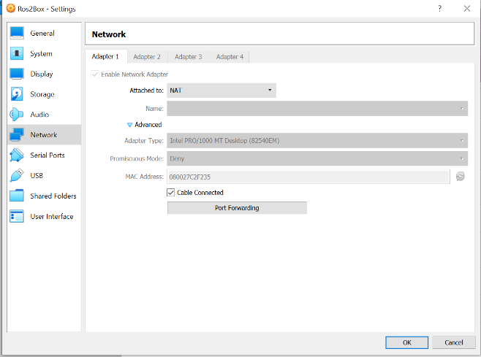

If you do not have a network adapter available, you can switch the “Attached to” from Bridge Adapter to Not Attached. Note that this will result in the virtual machine not having access to the internet. Access to the internet is highly recommended if you would like to have access to git repositories, personal files, etc.

Also ensure the Display shows an appropriate graphics controller I recommend “VMSVGA”. As shown:
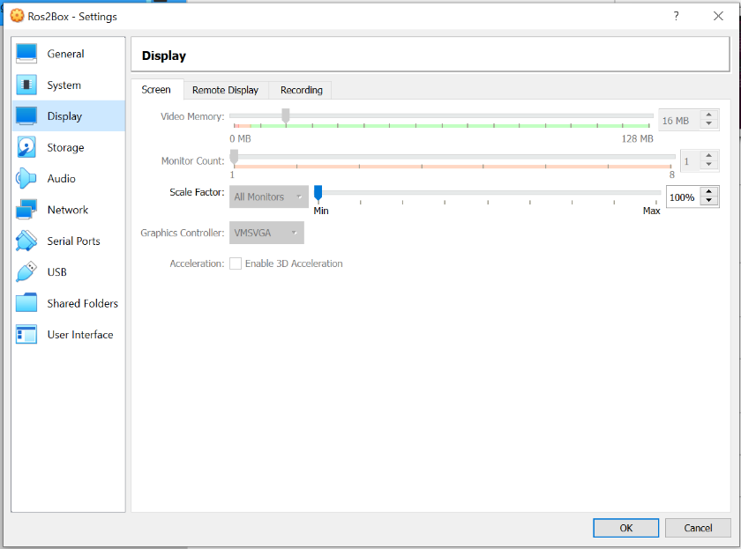
- Virtual Machine Start-up
Press the “Start” icon. Allow to virtual machine to launch. By default the username is “ros2box” and the password is “admin123”, this will be required for sudo privileges. You can change the password by typing “sudo passwd ros2box" and you can add yourself as your own user by “sudo adduser new_username”.

- Virtual Machine Shutdown
Virtual machines can be sensitive to appropriate startup and shutdowns. While you can simply close the window, this is the equivalent of turning off a workstation by pulling out the power cable, it can lead to corruption of the VM and an inability to restart the VM without serious recovery. Please shutdown the virtual machine using the “Power off” menu option in the Linux system and wait for the machine to fully shut down.

